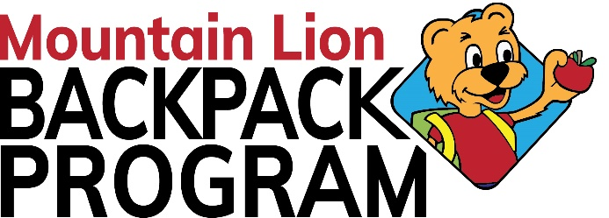
Mountain Lion Backpack Program
(Packing Location) The Nehemiah Project Building
1809-11th Street, Altoona PA 16601
(Office) 2301 Beale Ave, Altoona PA 16601
814-946-3651 Ext 108
MountainLionbp@blaircap.org
www.mountainlionbackpackprogram.org

Thank you for volunteering with the Mountain Lion Backpack Program!

Below is the packing schedule for the Mountain Lion Backpack Program 2023-2024 school year. Food bags are packed every Thursday evening during the school year, except in cases where there is no school on Friday. In those cases, packing nights are the night before the last day of the school week. These dates are written in bold italics below.

Packing begins at 5pm at the warehouse which is located at The Nehemiah Project building (The old Wright Elementary School) @ 1809-11th Street, Altoona. Please arrive early, so we are ready to start at 5pm.

In the event of schedule changes, announcements will be made on the Mountain Lion Backpack Program Facebook page and all group leaders will be notified. This schedule will only change in the event of changes to the school calendar from the school district or inclement weather.

If you have any questions or would like to volunteer, please contact Billie Egan at 814-946-3651, or David Aboud at 814-932-0081, or at mountainlionbp@blaircap.org
Follow us on Facebook and Instagram!

2023 2024 2024
Thursday, September 14 Thursday, January 4 Thursday, May 2 Wednesday, September 20 Thursday, January 11 Thursday, May 9
Thursday, September 28 Thursday, January 18 Thursday, May 16
Wednesday, January 24 Thursday, May 23
Thursday, October 5 (LEX send on 23rd)
Thursday, October 12 (No LEX) Thursday, February 1
Thursday, October 19 Thursday, February 8
Thursday, October 26 Wednesday, February 14
Thursday, February 22
Thursday, November 2 Thursday, February 29
Thursday, November 9
Thursday, November 16 Thursday, March 7(LEX delivered March 7)
Thursday, November 30 Thursday, March 14
Thursday, March 21
Thursday, December 7 Wednesday, March 27 (No LEX)
Thursday, December 14
Wednesday, December 20 Thursday, April 4
Thursday, April 11
Thursday, April 18
Thursday, April 25

