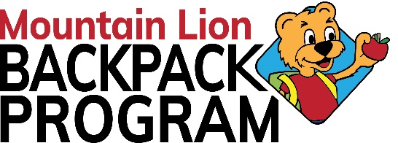
Mountain Lion Backpack Program
Office location
2301 Beale Avenue Altoona, PA 16601
(814) 946-3651 ext. 108
MountainlionBP@blaircap.org
www.mountainlionbackpackprogram.com

HOLD HARMLESS & WAIVER
I do hereby release, indemnify, and hold harmless Blair County Community Action-Mountain Lion Backpack Program, and their respective employees or volunteers from any and all liability, including but not limited to; injury, disability, death, loss, or damage to or destruction of personal property, and any and all costs of defense including attorney fees.
I acknowledge, understand, and agree that I have read this release of liability and assume any and all risks associated with my child getting their face painted during this event.
PERMISSION TO USE PHOTOGRAPH
Subject: Mountain Lion Backpack Program Volunteer Participation
I grant Blair County Community Action, its representatives, and employees the right to take photographs of me, my children, or my property in connection with the above-identified subject.
I authorize Blair County Community Action, its assigns, and transferees to copyright, use, and publish the same in print and/or electronically. I agree that Blair County Community Action may use such photographs of me, or my children, with or without my name and for any lawful purpose, including for example such purposes as publicity, illustration, advertising, and Web content. I have read and understand the above:

Printed name ____________________________ Signature ________________________________
(If under age 18, parent or guardian must sign)
Date____________________________________ Phone #__________________________________

