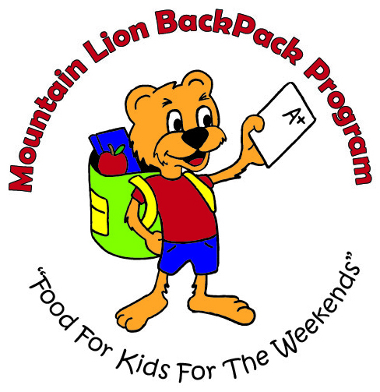

Volunteer Handbook
2017-2018
School Year

Welcome!

Thank you for your interest and taking the time out of your busy schedule to volunteer with the Mountain Lion BackPack Program!

Our volunteers are a vital part of the program and because of people like you we are able to provide food for over 1,200 Altoona Area School District elementary students for 32 weeks during the school year. Without our volunteers and the time they give the program would not be possible.

Program Overview

The mission of the Mountain Lion BackPack Program is “Feeding our youth so they may be hungry for knowledge.” The MLBP Program feeds over 1,200 Altoona Area Elementary school children every week. The program is part of the national Feeding America Network BackPack Program.

For many students, the meals at school are the only meals they may eat. Many return to school on Monday morning sick, tired, dizzy and unable to focus because of hunger. This is no way to be prepared to learn. The Mountain Lion Backpack Program (MLBP) is not just a feeding program, it is an educational program as well.

To help address their hunger and to better prepare them to learn, the MLBP Program provides students with backpacks of food every Friday for 32 weeks of the school year. The backpacks contain 2 breakfasts, 2 lunches, 2 dinners, 2 snacks and 2 drinks. Items may include cereal bowls, granola bars, raisins, ramen noodles, fruit cups, oatmeal, tuna, soup, peanut butter, etc. Surveys of both teachers and parents indicate positive change in school attendance, behavior and focus from children participating in the program.

To feed 1,200 students each week, it takes many community volunteers. Each school is ‘adopted’ by a neighborhood church, who helps fill and deliver the backpacks each week. Before the delivery can occur, food is placed in the backpacks at our Beale Avenue warehouse, the former Butterick plant. The volunteers then deliver backpacks to each school on the Thursday nights so the students can have them for Friday to take home.

Funding received will be used to purchase food that will be placed in the backpacks. The average cost is $3 a backpack, which is about $100 for 1 student per year. $2,500 will purchase food for 25 children for 1 school year or 32 weekends. Each week food would consist of 2 breakfasts, 2 lunches, 2 dinners, 2 snacks and 2 drinks. Items may include cereal bowls, granola bars, raisins, ramen noodles, fruit cups, oatmeal, tuna, soup, peanut butter, etc.

Our Mission
The mission of the Mountain Lion BackPack Program is to provide elementary children in the Altoona Area School District with food for the weekends when other resources may not be available to them.

- In providing school children with food, we hope to nourish their bodies, prepare their minds, and encourage their spirits.
- We hope to support the teachers of our school district with this program in that students will be more physically prepared to attend school regularly, focus more intently on their lessons, and demonstrate healthy attitudes.
- We hope to be an encouragement to families who are struggling, to both lift a burden and show that their community cares.
- We hope to bring our community together in this effort to touch and change lives, serving families not only with food but also with love and compassion.

This mission will be carried out with sincerity and determination and with great respect for those we serve.
Volunteer Roles & Eligibility

Why We Need You
The Mountain Lion BackPack Program relies on volunteers throughout the year, especially during our 32 weeks of packing during the school year. We wouldn’t be able to do what we do, if it wasn’t for the kindness and generosity of our volunteers.

Packing
Assembly line, placing food items in bags, and anyone is welcome
Students, kids, adults – anyone can help!

Other Eligibility Restrictions
Under Age 18: Must be accompanied by a parent/guardian, teacher, or group leader.

Neighborhood Teams – Delivery to Schools
All volunteers that are delivering to the elementary schools must have current clearances on file at the school they are delivering to. Clearances must be updated every 5 years. New volunteers must submit clearances before the start of delivery in October.

AASD Volunteer Forms can be obtained from the elementary school office, online at http://www.aasdcat.com/, or from the Mountain Lion BackPack Program.

2017-2018 Volunteer Form

This form must be filled out by all volunteers, including those volunteering without a parent/guardian under the age of 18. Forms must be on record with the Mountain Lion BackPack Program every year and only to be completed once, if volunteering on multiple occasions.

Name: ________________________________________________________________________

Home Address: _________________________________________________________________

City: ______________________________ State: __________ Zip: _______________________

Phone: ________________________________

Email: ________________________________________________________________________

Date of Birth: _______________________________ Age: ______________________________

Parent/Guardian Name if under 18: __________________________________________________

Organization/Group: ____________________________________________________________

I understand that I am volunteering for the Mountain Lion BackPack Program and will not hold the program, the Altoona Area School District, Blair County Community Action, its staff, other volunteers, and/or workers liable for any injury or loss before, during, or after my time volunteering with the Mountain Lion BackPack Program. I also, understand by signing, I hereby release that any photos taken during my time volunteering may be used by the Mountain Lion BackPack Program, including but not limited to promotion materials, marketing, our website, and/or social media accounts.

________________________________________ _____________________________
Volunteer Signature Date

________________________________________ _____________________________
Parent/Guardian Signature if under 18 Date

