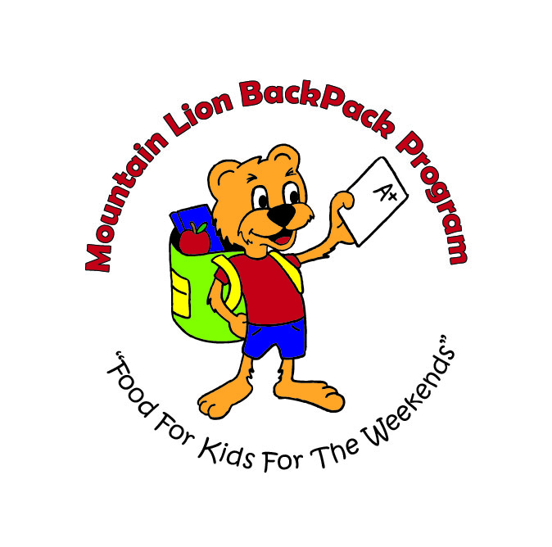
Mountain Lion BackPack Program
2301 Beale Avenue
Altoona, Pa 16601
814-946-3651 ext. 108
MountainLionBP@blaircap.org

Dear Friend,

The Mountain Lion BackPack Program is excited to announce our summer fundraiser!
This is your opportunity to become a sponsor and support our growing program!
Mountain Lion BackPack Program provides food for Altoona elementary school children over the weekend, when other food resources may not be available. Doing so fuels their bodies and minds to be prepared to learn Monday morning.
Mountain Lion BackPack serves 8 Altoona Area elementary schools and the pre-school at Learning Express, feeding 600 children every week. Surveys of both teachers and parents indicate positive changes in school attendance, grades, behavior, responsibility, and focus. Our program is growing; as the need is great. We hope to be feeding well over 1,000 children by fall.
Please join us for a pleasant evening of decadence and entertainment at our fundraiser “Corks and Hops.” A wine and beer tasting event. The event will be at the Blair County Convention Center on July 25, 2022. Attendees will enjoy wine and beer paired with appetizers, hors d'oeuvres and desserts. Live entertainment from 6-10pm; featuring the local band “Ages.” It promises to be an enjoyable evening of fun and dancing with your favorite breweries and wineries!

Please consider becoming a sponsor as a way to market your business and help feed local elementary school students, better preparing them for success on Monday mornings.
The names of all donors will be recognized. Sponsors will also receive tickets to the event compensatory with the sponsorship level. Please see the enclosed letter for details. This is an excellent opportunity for you and your company to support our local elementary school students and provide them with an opportunity to learn, free from the distraction of hunger. Mountain Lion BackPacks is a 501c (3) non-profit organization. At least 75% of every $1 donated is used toward the purchase of food.

Please contact us for any additional information you may need at (814) 946-3651 or (240) 609-9557. Please complete the enclosed sheet and return it to us at the address at the top of this letter. Thank you so much for considering this request. We hope to see you at the Corks & Hops!

Sincerely,

Kelly Robertson
Program Director

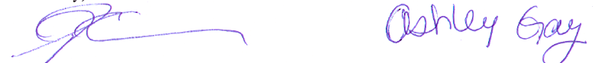
All contributors will be listed in the program. Please email a high resolution logo to mountainlionbp@blaircap.org

Mountain Lion BackPack program is a non-profit program through Blair County Community Action. All contributions are tax deductible to the fullest extent of the law.
Mountain Lion BackPack Program
2301 Beale Ave.
Altoona, PA 16601
814-946-3651 ext. 108
MountainLionBP@blaircap.org
Corks & Hops Sponsorship
We are delighted to sponsor at the following level…

_______ $1,000 “Platinum” Sponsor includes logo/name on tickets, front of programs, publicity in all printed materials company name and logo recognition on our website and other web-based advertising including social media with link to your company’s website. Publicity in all media coverage (print, television, and radio), signage at the event with name and logo, and 6 Corks & Hops event tickets.

_______ $500 “Brew master” Sponsor includes logo/name in programs, publicity in all printed materials (not including tickets). Company name and logo recognition on our website and other web-based advertising including social media. Signage at the event with name and logo, and 5 Corks & Hops event tickets.

________$400 “Pairings” Sponsor includes logo/ name in programs, publicity in all printed materials (not including tickets) Company name and logo recognition on our website and other web-based advertising including social media. Signage at the event with name and logo, and 4 Corks & Hops event tickets.

_______ $250 “Wine Pourers” Sponsor includes logo/ name in program, publicity in all printed materials (not including tickets), Company name and logo recognition on social media. Signage at the event with name and logo, and 3 Corks & Hops event tickets.

_______ $100 “Friends of the Program” includes name in program and name on signage at the event.

I/We would like to purchase ________ additional Corks & Hops tickets $50 each or $75 for a couple
All tickets include 6 sampling tickets

Sponsorship Support $

Extra Tickets $
Total Amount Enclosed $

Name (as it will appear on acknowledgement materials)
_{Key Contact}
_{Address}
_{City} _{State} _{Zip Code} _{Phone}
_{Email address}

Please make checks payable to Mountain Lion BackPack Program
~Tax-deductible as allowed by law, goods and services valued at $50 will be provided in exchange for each ticket~

Thank you!!

